**LINEAR SEARCH**

**ALGORITHM:**

**1.**START

**2.**Read the array .

**3.**Read the element to find the in array and store in variable key.

**4.**i=0;

**5.**while i value less than size of the array

// Check the value with i as index in the array is equal to the value in key.

**6.**if key value is equal to current value assign flag=1 and goto 8

**7.**else increment i.

**8.**if flag is 1 print element is found .

**9.**STOP.

**FLOWCHART**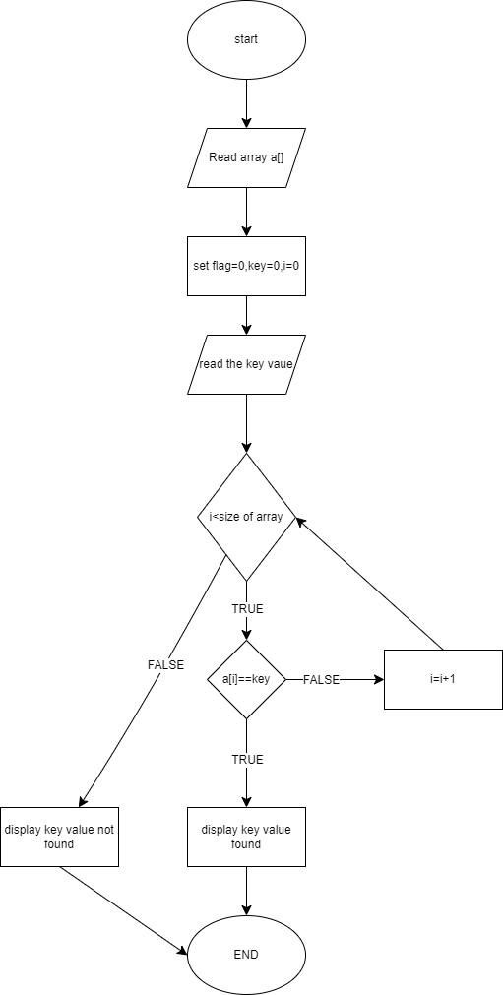

#include<stdio.h>

void main(){

int a[]={7,3,4,2,1,9,8};

int key=0,i=0,flag=0;

printf("enetr the element to find in the list");

scanf("%d",&key);

while(i<7){

if(a[i]==key)

{

flag=1;

break;

}i++;

}

if(flag==1)

printf("elemnt found at the position %d",i);

else

printf("elemnt not found ");

}